Kankara, Sudharshan Reddy

**Team D** **–** Phoenix

**Client:** Dr. Michael Oudshoorn

**Project –** Project Management Collaboration Tool

**Role –** Requirements Management

**ITERATION PLAN:**

My role in this project is requirements management. I am responsible for gathering requirements for the project, maintaining and updating them as per client and project. Also, I need to make sure that these requirements are met. I worked for about 38 hours last week. We have completed about 20% of the project. We are on track in completing the requirements and currently designing prototypes for our project.

**Project Requirements:**

Prototype - Have completed about 20% of the prototypes and on track in completing about 60% of the prototypes for our project by the end of this week. This is highly critical as we need to get this completed by the end of GDP 1.

**What I accomplished last week:**

I have completed writing requirements for messaging and concluded it. I have written test cases for messaging. I have designed prototypes for shared calendar and login/signup with sanjay and have completed cost/time estimation document.

**What I will be accomplishing this week:**

I will work on completing the prototype for messaging and document all the test cases for the same. I will work on completing the requirements for messaging and proof read the requirements for task management. I am also going to work on data management plan for our project along with baradwaj.

**Unresolved issues or blockers:**

There are no unresolved issues or blockers at this time of the project.

**Riskiest component under development:**

I think that gathering the requirements is the riskiest component in the entire project because this is what we will be working on throughout our project.

**Active efforts that are most critical for client acceptance or GDP completion:**

The most critical component for client acceptance or GDP completion is understanding the client requirements and completing them on time.

**Previous week submission:**

Kankara, Sudharshan Reddy

**Team D** **–** Phoenix

**Client:** Dr. Michael Oudshoorn

**Project -** Slack/Hipchat collaboration tool

**Role –** Requirements Management

**ITERATION PLAN:**

My role in this project is requirements management. I am responsible for gathering requirements for the project, maintaining and updating them as per client and project. Also, I need to make sure that these requirements are met. I worked for about 38 hours last week in understanding the working of chatting applications, gathering requirements and understanding the project that we need to complete. We have completed 12% of the project. We are on track in obtaining the requirements.

**Project Requirements:**

Requirements document - Have completed about 45% of the requirements document and on track in completing about 70% of the requirements for our project. This is highly critical as we need to get this completed by the end of GDP 1.

**What I accomplished last week:**

I have researched on the working of different chatting applications to find out the possibilities for our project. After this research, I have come up with some requirements that are feasible for our project and have also documented those requirements. I have created use case for the chatting application.

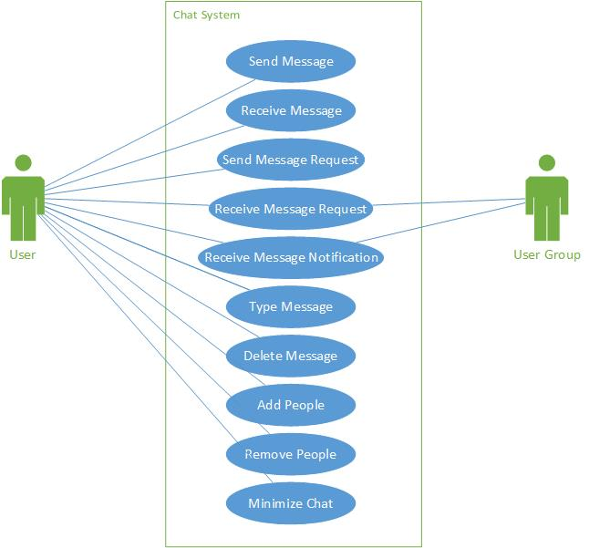

**What I will be accomplishing this week:**

I will work on requirements document and get it completed as detailed as I can. I will also work on cost/time effort estimation along with vineeth and get it completed. I will research on different types of databases that might be helpful for our project. By the end of next I will have completed requirements document, cost/time effort estimation document and have a good enough idea on different databases that will help us in completing our project.

**Unresolved issues or blockers:**

There are no unresolved issues or blockers at this time of the project.

**Riskiest component under development:**

I think that gathering the requirements is the riskiest component in the entire project because this is what we will be working on throughout our project.

**Active efforts that are most critical for client acceptance or GDP completion:**

The most critical component for client acceptance or GDP completion is understanding the client requirements and completing them on time.